**MINISTRY OF EDUCATION AND SCIENCE OF UKRAINE**

**KHARKOV NATIONAL UNIVERSITY OF**

**RADIOELECTRONICS**

Education Center in English

Student of Specialty Computer Engineering

**Subject**: **Internet Technology**

Laboratory Work Report No: 2

|  |  |
| --- | --- |
| **Student**: | **Course Chief:** |
| Ngwu Victor | Ganna Zavolodko |
| KIYKLI: 18-2 |  |

**2021**

Task 1 (First html script)

1.       Create an html-document according to the brief of the selected option. You can use the directory to help with tags and their attributes.

In the markup of the document to use:

-       tag to determine the encoding of the Cyrillic <meta>;

-       comment tag <! - ->;

-       text formatting tags: <p>, <br>, <div>, <span>, <hr>, <h1>, <h6>, <b>, <i>, <u>, <sub>, < sup>, <pre>, <tt>, show the differences between the tags <p> and <br>, <div> and <span>;

-       tag for image markup <img>;

-       make markup without using <div>.

2.       Test the created document in at least two browsers, note the differences in the display of the document.

3.       Post to a new branch of the project in GitHub.

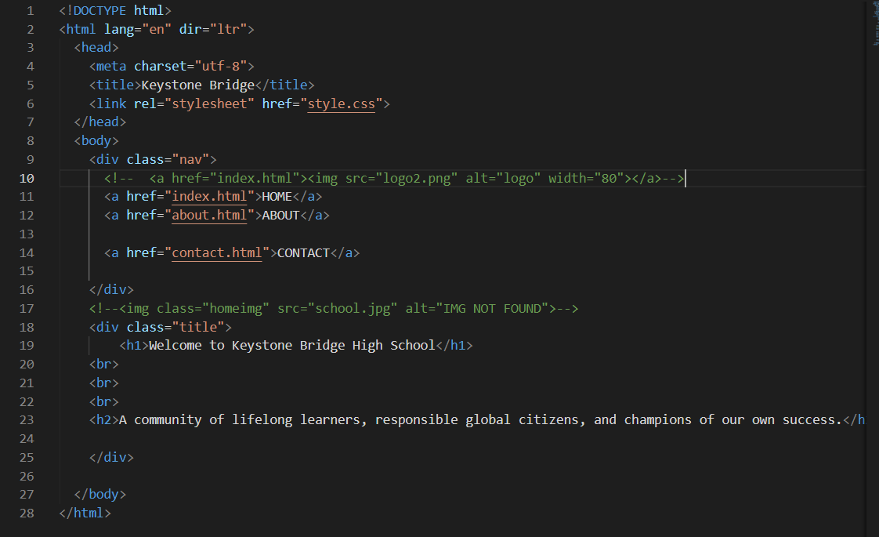

Figure 1. This is screenshot of part of the code for the school site.

### Task 2 (first CSS)

1.       Select the main page and template (html-document) of the approved version of the site.

2.       The page should contain elements from task 1 and additional elements:

-       text (font, size, color, margins, borders);

-       hyperlinks (colour of unvisited and visited links);

-       document (background);

-       list (markers or numbering);

-       table (borders, background).

3.       Create cascading style sheets of site presettings :

-       Site layout

-       Additional page styles

4.       Use style definitions for tags and style classes, pseudoclasses as appropriate as the DOM model. Follow the DRY method of writing.

5.       Use three ways to define cascading style sheets:

-       using the <link> tag;

-       using the <style> tag;

-       using the style parameter of the tag.

6.       Demonstrate the effect of priorities when using different methods of determining CSS.

7.       Provide a report and a link to the GitHub project committee

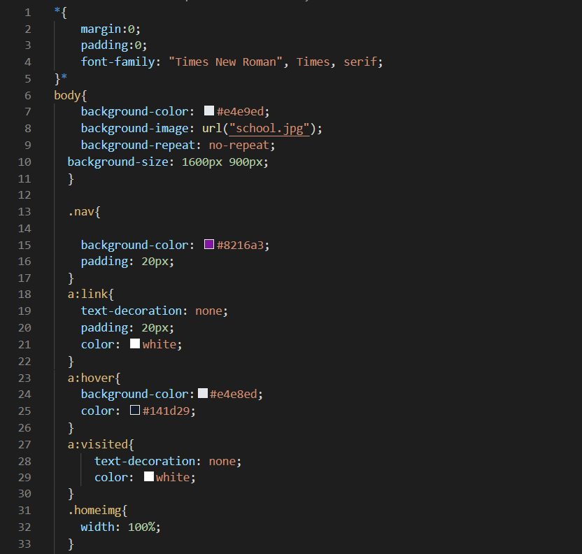

Figure 2 is the screenshot for part of the code of the CSS file for the main html file



Figure 3 is the screenshot from the website created

### Task 3 (Setting)

. Set the following default parameters for all paragraphs (overriding the <p> tag and pseudo classes of the <p> tag):

• paragraph alignment;

• paragraph indent;

• the size and color of the first letter.

2. Check the efficiency.

3. Explain these parameters in the comments (in the main.css file).

Task 3.

1. Set the following link properties by default for all pages:

• - color and design of the link;

• - color and design of the visited link;

• - color and design of the active link;

• - color and design of the link, at the time of finding the mouse cursor over it.

2. Check the efficiency.

3. Explain these parameters in the comments (in the main.css file).

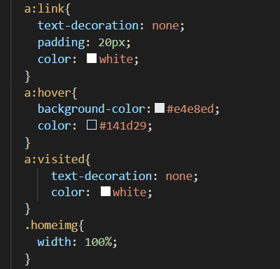

**Conclusion**

Using Microsoft visual studio code, we were able to perform a set of tasks for the lab such as creating of the html and CSS files. As you can see in figures 1-4 above, the task was successfully performed. As a result, a greater understanding on html and CSS has been gained. A link to the task is provided below:

https://github.com/NgwuVictor/Internet-Technology/tree/it-task-2